Released Apr2025

Account Receivable
- Account Receivable - Apply Contract - Add features to revise invoice description and currency rate before apply invoice
  - Note : Allow to revise description and currency rate before generating invoice
  - From : Account Receivable > Procedure > Apply Contract
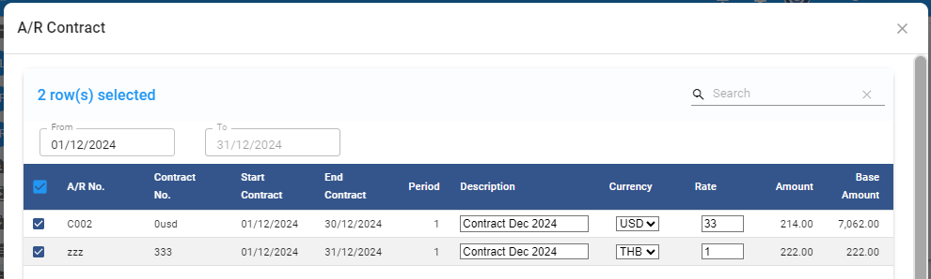
- Account Receivable - Receipt - fix the calculation of available credit
  - Note : When select and deselect invoice, the available credit is not correct.
  - From : Account Receivable > Receipt

General Ledger
- General Ledger - Posting from AP - fix bug for dimension in AP not post to GL
  - Note : When record dimension in AP invoice, system will post dimension value to GL
  - From : General Ledger > Procedure > Posting from AP

- General Ledger - Financial Report - new features to view P&L right in the systems
  - Note : Built in Financial report with standard format. It require account code mapping before use.
  - From : General Ledger > Financial Report
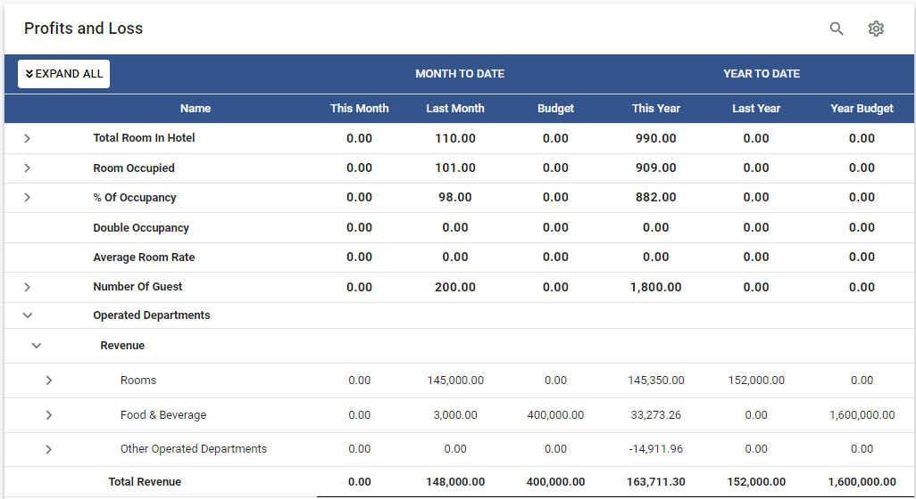
- General Ledger - Financial Report - new features to view Balance Sheet right in the systems
  - Note : Built in Financial report with standard format. It require account code mapping before use.
  - From : General Ledger > Financial Report
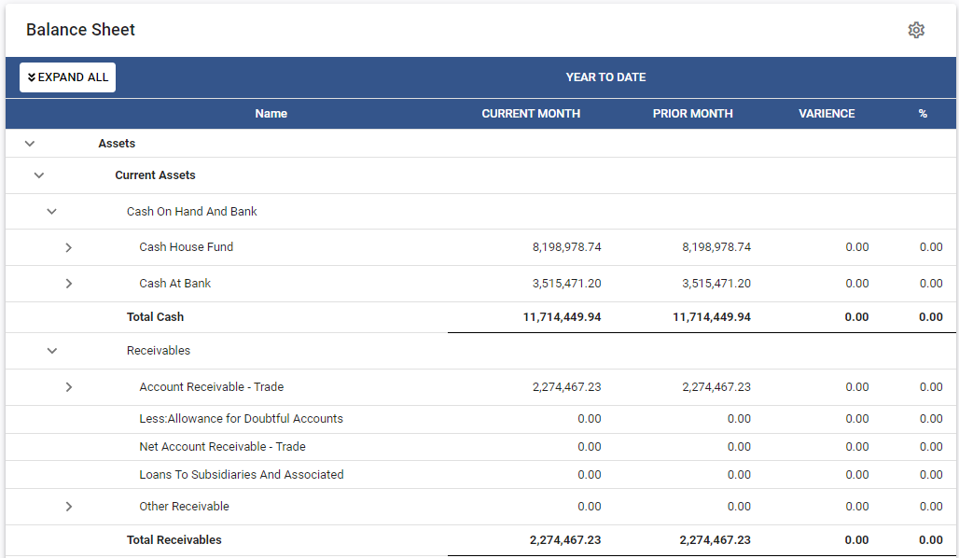

Configuration
- Configuration - COA - new features to reverse sign for presenting in Built in financial report
  - Note : This features will affect to presenting the amount in Built in financial report only. It will reverse the sign of amount.
  - From : Configuration > Chat of Account

- Configuration - COA - remove default value for nature and type in Chart of accounts
  - Note : System will not set default value for nature and type to avoid save without review.
  - From : Configuration > Chat of Accounts

